Experiment No: 3
Date: 14-01-2011

BRESENHAM’S CIRCLE DRAWING ALGORITHM

PROBLEM DEFINITION

Write a program to implement Bresenham’s circle drawing Algorithm

THEORETICAL BACKGROUND
Bresenham's circle algorithm (also known as a midpoint circle algorithm) is an algorithm for determining the points needed for drawing a circle with a given radius and origin for the circle. Scan converts a circle of a specified radius, centered at the specified location. Scan conversion is performed using a Bresenham-style midpoint decision approach to compute pixels in one octant of the circle (from x = 0 to x = y = R/sqrt(2). Points in other octants are drawn via symmetry.
At each step of the iteration, we:
- Determine whether to move east (E) or south-east (SE) based on the sign of the decision variable 'd'.
- d < 0 ==> move E (i.e. x' = x+1, y' = y)
- d >= 0 ==> move SE (i.e. x' = x+1, y' = y-1)
- Update the decision variable with a delta-value that depends on the direction selected
- Update the delta-values based on the move direction
- Draw a pixel at x', y'
The algorithm starts accordingly with the circle equation x² + y² = r². We consider first only the first octant and draw a curve which starts at point (r,0) and proceeds upwards and to the left, reaching the angle of 45°.The "fast" direction here is the y direction. The algorithm always does a step in the positive y direction (upwards), and every now and then also has to do a step in the "slow" direction, the negative x direction. The frequent computations of squares in the circle equation, trigonometric expressions or square roots can again be avoided by dissolving everything into single steps and recursive computation of the quadratic terms from the preceding ones. From the circle equation we obtain the transformed equation

0=x² + y² − r² , with r² to be computed only a single time during initialization:

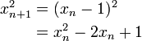

and accordingly for the y-coordinate. Additionally we need to add the midpoint coordinates when setting a pixel. These frequent integer additions do not limit the performance much, as we can spare those square (root) computations in the inner loop in turn. Again the zero in the transformed circle equation is replaced by the error term. The initialization of the error term is derived from an offset of ½ pixel at the start. Until the intersection with the perpendicular line, this leads to an accumulated value of r in the error term, so that this value is used for initialization.

ALGORITHM

Step1: Start
Step2: Initialize the graphics driver and call the function initgraph
Step3: Initialize x as 0 and substitute r to y
Step4: Calculate p
Step5: Do the following till x is less than y
5.1: Give x as x+.1
5.2: If p is less than 0 then put
5.2.1: Assign p as p+4x+6 otherwise
5.2.2: Decrement y by .1
5.2.3: Calculate p as p+4(x-y)+10
Step6: Call putpixel function for different values of x, y, and color indicating value
Step7: Stop

PROGRAM DEVELOPMENT

#include<graphics.h>
#include<stdlib.h>
#include<stdio.h>
#include<math.h>
void main()
{
int x,y,r;
float x1,p,y1;
int gdriver=DETECT,gmode,errorcode;
initgraph(&gdriver,&gmode,"C:\\TC\\BGI");
printf("Enter the centre coordinates\n");
scanf("%d %d",&x,&y);
printf(“Enter the radius\n”);
scanf(“%d”,&r);
x1=0;
y1=r;
p=3-(2*r);
while(x1<y1)
{
x1=x1+.1;
if(p<0)
p=p+(4*x1)+6;
else
{
y1=y1-.1;
p=p+(4*(x1-y1)+10);
}
putpixel(x+x1,y+y1,10);
putpixel(x-x1,y-y1,4);
putpixel(x+x1,y-y1,10);
putpixel(x-x1,y+y1,4);
putpixel(x+y1,y+x1,10);
putpixel(x-y1,y-x1,4);
putpixel(x+y1,y-x1,9);
putpixel(x-y1,y+x1,10);
}
getch();
}

TESTING STRATAGIES

Test Case1:
To plot a circle with centre coordinates (200, 200) and radius 100.

Test Case2:
To plot a circle with centre coordinates (100, 100) and radius 50.

SUMMARY OF RESULTS

Case 1:
Enter the center coordinates
200 200
Enter the radius
100


Case 2:
Enter the center coordinates
100 100
Enter the radius
50



CONCLUSION

The program to implement Bresenham’s circle drawing algorithm was developed and tested successfully.
Program No :4
Date: 141-01 -2011

MIDPOINT ELLIPSE ALGORITHM

PROBLEM DEFINITION

Write a program to implement mid point ellipse algorithm

THEORETICAL BACKGROUND

Midpoint ellipse algorithm is a method for drawing ellipses in computer graphics.

This method is modified from Bresenham’s algorithm. The advantage of this modified method is that only addition operations are required in the program loops. This leads to simple and fast implementation in all processors.

Let us consider one quarter of an ellipse. The curve is divided into two regions. In region I, the slope on the curve is greater than –1 while in region II less than –1. Consider the general equation of an ellipse,

b2x2 + a2y2 – a2b2 = 0

where a is the horizontal radius and b is the vertical radius, we can define an function f(x,y) by which the error due to a prediction coordinate (x,y) can be obtained. The appropriate pixels can be selected according to the error so that the required ellipse is formed. The error can be confined within half a pixel.

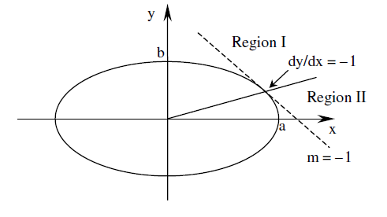

Set f(x,y) = b2x2 + a2y2 – a2b2

In region I (dy/dx > –1), x is always incremented in each step, i.e. xk+1 = xk + 1. yk+1 = yk if E is selected, or yk+1 = yk – 1 if SE is selected. In order to make decision between S and SE, a prediction (xk+1, yk–½) is set at the middle between the two candidate pixels. A prediction function Pk can be defined as follows:

Pk = f(xk+1, yk–½)
= b2(xk+1)2 + a2(yk–½)2 – a2b2
= b2(xk2 + 2xk + 1) + a2(yk2 – yk + ¼) – a2b2

If Pk < 0, select E :
Pk+1^E = f(xk+2, yk–½)
= b2(xk+2)2 + a2(yk–½)2 – a2b2
= b2(xk2 + 4xk + 4) + a2(yk2 – yk + ¼) – a2b2

Change of Pk^E is: DPk^E = Pk+1^E – Pk = b2(2xk + 3)
If Pk > 0, select SE :
Pk+1^SE = f(xk+2, yk–3/2)
= b2(xk+2)2 + a2(yk–3/2)2 – a2b2
= b2(xk2 + 4xk + 4) + a2(yk2 – 3yk + 9/4) – a2b2
Change of Pk^SE is DPk^SE = Pk+1^SE – Pk = b2(2xk + 3) – 2a2(yk – 1)
Calculate the changes of DPk:
If E is selected,
DPk+1^E = b2(2xk + 5)
D2Pk^E = DPk+1^E – DPk^E = 2b2
DPk+1^SE = b2(2xk + 5) – 2a2(yk – 1)
D2Pk^SE = DPk+1^SE – DPk^SE = 2b2

If SE is selected,
DPk+1^E = b2(2xk + 5)
D2Pk^E = DPk+1^E – DPk^E = 2b2
DPk+1^SE = b2(2xk + 5) – 2a2(yk – 2)
D2Pk^SE = DPk+1^SE – DPk^SE = 2(a2 + b2)

Initial values:
x0 = 0, y0 = b, P0 = b2 + ¼a2(1 – 4b)
DP0^E = 3b2, DP0^SE = 3b2 – 2a2(b – 1)
In region II (dy/dx < –1), all calculations are similar to that in region I except that y is
decremented in each step.

ALGORITHM

- Start.
- Input rx, ry, and ellipse centre (rc,yc) and obtain the first point on an ellipse
centered on the origin as (x0,y0) =(0,ry).
- Calculate the initial value of the decision parameter in region 1 as
p10=ry*ry-rx*rx*ry+0.25*rx*rx.
- At each x_{k} position, in region 1, starting at k=0, perform the following test :
If p1k<0 , the next point along the ellipse centered on (0,0) is c(x_{k+1 ,} y_{k}) and
p1 _{k+1} = p1 _{k}+2*ry*ry* x_{k+1} + ry*ry.
Else, the next point along the circle is (x_{k}+1 , y_{k}-1) and
p1 _{k+1} = p1 _{k}+2*ry*ry* x_{k+1} -2* rx*rx y_{k+1} + ry*ry.
with
2*ry*ry* x_{k+1} = 2*ry*ry* x_{k} + 2*ry*ry.
2*rx*rx* x_{k+1} = 2*rx*rx* y_{k} - 2*rx*rx.
and continue till 2*ry*ry*x>= 2*rx*rx*y.
Step 5: Calculate the initial value of the decision parameter in region 2 using the last
point (x0,y0) calculated in region 1 as
p20 = ry*ry*(x0 + 0.5)*(x0+0.5) + rx*rx(y0-1)*(y0-1) – rx*rx*ry*ry.
Step 6: At each y_{k} position in region 2 , starting at k=0, perform the following test :
If p2 _{k} >0 , the next point along the ellipse centered on (0,0) is (x_{k ,} y_{k}-1) and
p2 _{k +1}= p2 _{k}-2* rx*rx*y_{k+1} +rx*rx.
Else,
the next point along the circle is (x_{k} +1, y_{k}-1) and
p2 _{k +1}= p2 _{k}+2* ry*ry* x_{k+1} +rx*rx -2* rx*rx*y_{k+1}
using the same incremental calculations for x and y as in region 1.
Step 7 : Determine symmetry points in the other three quadrants.
Step 8: Move each calculated pixel position ( x,y) onto the elliptical path centered on
(xc,yc) and plot the co-ordinate values: x=x+xc, y = y+yc.
Step 9: Repeat the steps for region 1 until 2*ry*ry*x >=2*rx*rx*y.

PROGRAM DEVELOPMENT

#include<stdio.h>
#include<conio.h>
#include<graphics.h>
#include<math.h>
#define ROUND(a) ((int)(a+0.5))
void ellipseMidpoint(int,int,int,int)
void ellipsePlotPoints(int,int,int,int)
void main()
{
int rx,ry,xcenter,ycenter;
int gd=DETECT,gm;
initgraph(&gd,&gm,” “);
printf(“enter the center\n”);
scanf(“%d %d ”,&xcenter,&ycenter);
printf(“enter a and b\n”);
scanf(“%d %d”,&rx,&ry);
eliipseMidpoint(xcenter,ycenter,rx,ry);
getch();
closegraph();
}
void ellipsemidpoint(int xcenter,int ycenter,int rx,int ry)
{
int rx2=rx*rx;
int ry2=ry*ry;
int tworx2=2*rx2;
int twory2=2*ry2;
int p,x=0;
int y=ry;
int px=0;
int py=tworx2*y;
ellipsePlotPoints(xcenter,ycenter,x,y);
p=ROUND(ry2-(rx2*ry)+(0.25*rx2));
while(px<py)
{
x++;
px+=twory2;
if(p<0)
p+=ry2+px;
else
{
y--;
py-=tworx2;
p+=ry2+px-py;
}
ellipsePlotPoints(xcenter,ycenter,x,y);
p=ROUND(ry2*(x+0.5)*(x+0.5)+rx2*(y-1)*(y-1)-rx2*ry2);
while(y>0)
{
y--;
py-=tworx2;
if(p>0)
p+=rx2-py;

else
{
x++;
px+=twory2;
p+=rx2-py+px;
}
ellipsePlotPoints(xcenter,ycenter,x,y);
}
}
void ellipsePlotPoints(int xcenter,int ycenter,int x,int y)
{
putpixel(xcenter+x,ycenter+y,255);
putpixel(xcenter-x,ycenter+y,255);
putpixel(xcenter+x,ycenter-y,255);
putpixel(xcenter-x,ycenter-y,255);
}

TESTING STRATEGIES

Test case 1: Entering values such that a>b (a: horizontal radius, b: vertical radius)
Test case 2: Entering values such that a<b (a: horizontal radius, b: vertical radius)
Test case 3: Entering values such that a=b (a: horizontal radius, b: vertical radius)

SUMMARY OF RESULTS

Case1:
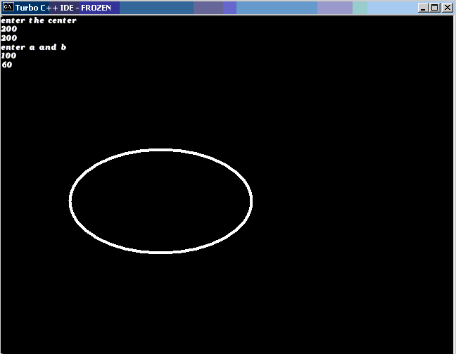

Case2:
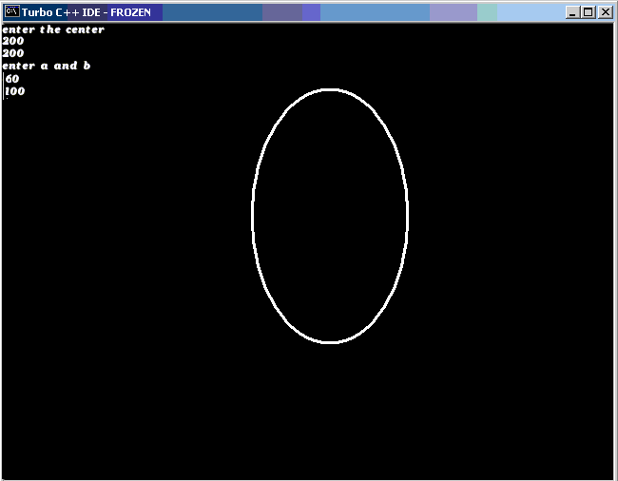
Case 3:
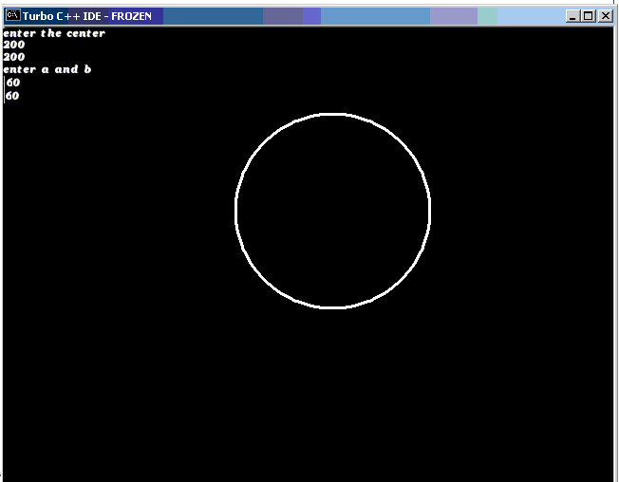

CONCLUSION

The program was to implement a mid point ellipse algorithm. Program was coded and the output was obtained successfully.

